# CA_Plymouth_logo_PosterCitizens Advice Plymouth

**Title:** Pension Wise Guidance Specialist

**Employer:** Citizens Advice Plymouth

**Salary:** £24,539.37 increasing to £25,893.24 following successful completion of 6 months probationary period

**Hours:** Full Time 37 hours per week

**Contract:** Permanent

**Responsible to:** Pension Wise Project Leader (Southwest)

**Work Base:** Devon

**Apply:** Please send your CV and a statement explaining how you meet the person specification to [recruitment2@plymouthcab.org.uk](mailto:recruitment2@plymouthcab.org.uk)

For an informal chat about the role, please contact Ruth Lisney, Project Leader [Ruth.Lisney@plymouthcab.org.uk](mailto:Ruth.Lisney@plymouthcab.org.uk)

**Closing date:** Friday 8th November 2019 at 1700

**Notification Period:** If shortlisted for interview we will contact you by

Friday 15th November 2019

**Interview date:** Tuesday 19th November 2019 at Taunton Citizens Advice

**Overall purpose of the role:**

To deliver a specialist quality service to customers eligible for the pensions guidance service who have complex pension scenarios by supplying accurate, personalised, relevant information and guidance on their pension’s options and choices.

The following are the main duties of the role:

1. Provide face to face pension and retirement information and guidance to members of the public, in line with the defined Pension Wise service.

2. To help consumers to understand the full implications of their pension choices, using appropriate skills, including numerical.

3. To raise consumer awareness of pension scams and fraudulent activity, to encourage consumers to report any issues to the relevant authorities and to report potential scams and fraudulent activity through appropriate internal channels.

4. Respond proactively to consumer demand, working to agreed service delivery standards.

5. Provide timely and accurate follow up information that adds value to the consumer and is clear and easy to understand.

6. Contribute towards shared best practice within the local centre and across the local Citizens Advice (LCA) network.

7. Ensure that all work conforms to the Pension Wise quality standards, including undertaking peer to peer observations for quality assurance purposes, where applicable.

8. Ensure that all required management information is both captured and reported on a timely basis.

9. Complete training, continuous professional development and other requirements to gain and maintain accreditation.

10. In addition, you may be required to carry out ad hoc projects to improve the service we provide, attend meetings or workshops and support promotional activity for the service, within the scope of the role.

**Professional development**

* Undertake appropriate CPD as required in order to continue to meet the competencies of the role
* Attend relevant internal and external meetings as agreed with your line manager.
* Prepare for and attend supervision sessions / team meetings/ staff meetings as appropriate.

**Other duties and responsibilities**

* Complete the required training to comply with quality assurance processes.
* Ensure that all work conforms to Citizens Advice systems, policies and procedures.
* Carry out any other tasks that may be within the scope of the post to ensure the effective delivery and development of the service.
* Demonstrate commitment to the aims, policies, values and principles of the Citizens Advice Service.
* Abide by health and safety guidelines and share responsibility for your own safety and that of colleagues.

**Person Specification:**

**Essential**

1. Numerical skills to understand financial matters, so that the individual is empowered to take personal action.

2. Must have a good foundation knowledge of pensions law and practice, gained in a pension’s technical role.

3. Must have a thorough understanding of a broad range of pension arrangements, both occupational and personal, gained working in a pension’s technical role.

4. An understanding and appreciation of wider retirement issues.

5. Proven ability in financial capability and an understanding of the issue’s consumers face in trying to manage their money.

6. Strong questioning skills and the ability to get to understand key client issues whilst maintaining structure and control during the course of a client interview.

7. Ability to translate complex ideas and topics into clear, concise and engaging content that the general public are able to understand.

8. Ability to identify connecting advice issues and assess an individual’s ability to take action.

9. Effective communication skills. The ability to build a rapport, communicate confidently, sensitively and professionally, using oral and written techniques.

10. Proven ability to work on own initiative – to monitor and maintain own standards and meet qualitative and quantitative targets for service delivery.

11. Proven organisational and time management skills.

12. Flexibility and willingness to work as part of a team.

13. Understanding of and commitment to the aims and principles of the LCA service.

14. A commitment to ongoing personal and professional development including continuing professional development to gain and maintain accreditation for the role.

**Desirable**

1. APMI or CII qualifications or equivalent in related areas would be of benefit.

2. Willingness to travel within the UK (including occasional overnights) and to work unsocial hours occasionally to meet tight timescales.

3. Proven ability to use IT packages

**Important information**

Successful applicants are made a conditional offer subject to:

1. HM Government Baseline Personnel Security Standard (BPSS)

2. Successful completion and passing of accreditation training and exam

3. Satisfactory references

4. Depending on role requirements: DBS checks

**Aims, Principles & Behaviours**

**Aims**

To provide the advice people need for the problems they face.

To improve the policies and practices that affect people's lives.

The service provides free, independent, confidential and impartial advice to everyone on their rights and responsibilities.

**Principles**

We provide free, independent, confidential and impartial advice to everyone on their rights and responsibilities. We value diversity, promote equality and challenge discrimination.

**Values**

Responsible: We’re informed and honest

Generous: We’re compassionate and collaborative

Inventive: We’re problem-solving and forward-thinking

**Behaviours Framework**

1. A commitment to the aims and principles of the Citizens Advice service in everything we do.
2. A passion for encouraging open debate to resolve issues to improve our services to clients.
3. A “no surprise” management culture in the delivery of “promises” & commitments within a full disclosure environment. Leaders will “walk the talk” not “talk the talk.
4. Everyone has leadership responsibilities to be a positive role model, bringing enthusiasm into the working environment. You don’t need permission!
5. A “no same mistake tolerant, no fear culture”.
6. Respectful & professional in all interactions with clients, colleagues & external stakeholders.
7. Harness the power of teamwork – but not as an abdication of individual accountability.
8. Working within cross-functional teams with no silo mentality
9. Our meetings will be decision or idea focused with clear outcomes and/or solutions.
10. A passion for health, safety, wellbeing and the environment underpinned by our policies.

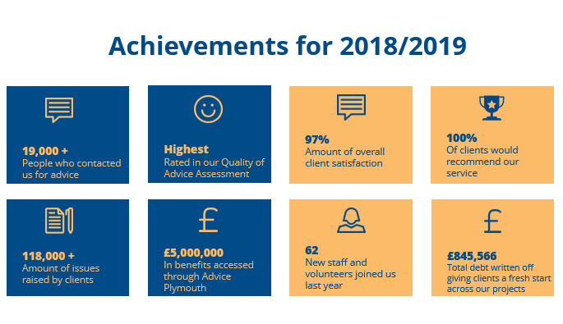

** 3 things you should know about Citizens Advice**

**1. We’re local and we’re national**. We have 6 national offices and offer direct support to people in over 290 independent local Citizens Advice services across England and Wales.

**2. We’re here for everyone.** Our advice helps people solve problems and our advocacy helps fix problems in society. Whatever the problem, we won’t turn people away.

**3. We’re listened to - and we make a difference.** Our trusted brand and the quality of our research mean we make a real impact on behalf of the people who rely on us.